**AWS 101 EBS : Creating Django application using Elastic Beanstalk**

*Posted On September 11, 2019*

The following task will help you to create, view, manage, create, deploy an application, create its instance alarm and edit and terminate your EBS environment.

**Login to AWS console**

For new user, sign up to [console.aws.amazon.com](http://console.aws.amazon.com/). If already having console account, you can access Elastic Beanstalk of Amazon Web Services for creating and managing various kinds of environment. Other services that will come and be useful with EBS would be Amazon Elastic Compute Cloud( for creating instances), Amazon Notification Services(Alarm) , Amazon S3( Object Storage Provider).

**Open Elastic Beanstalk Console and Create an Application**

**Open the**[**Elastic Beanstalk console**](https://console.aws.amazon.com/elasticbeanstalk). EBS is free to use but since the application goes live therefore , it incur standard charge unless you are using Free Tier (*conditions apply). 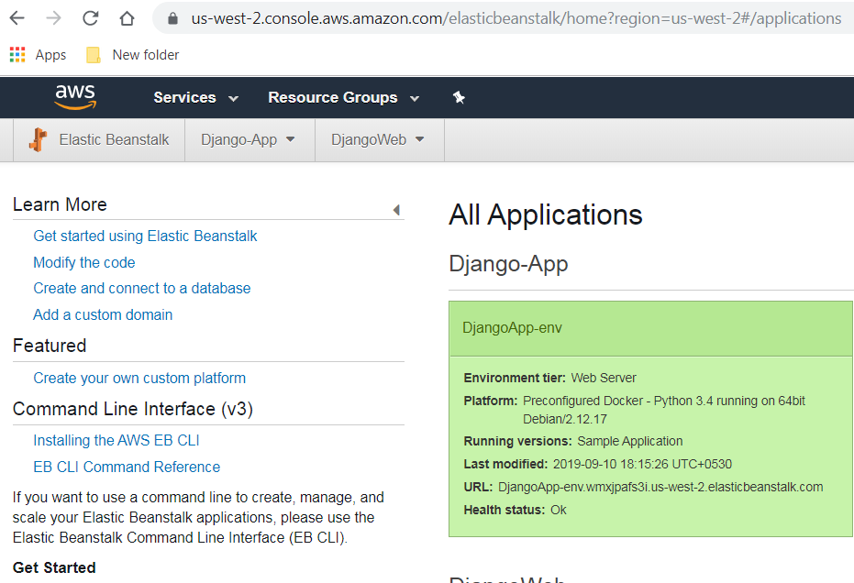 Above image representation shows the AWS EBS application deployed US-west-2 region and is home page when you navigate to EBS console. **Click on**<https://us-west-2.console.aws.amazon.com/elasticbeanstalk/home?region=us-west-2#/gettingStarted?applicationName=getting-started-app> 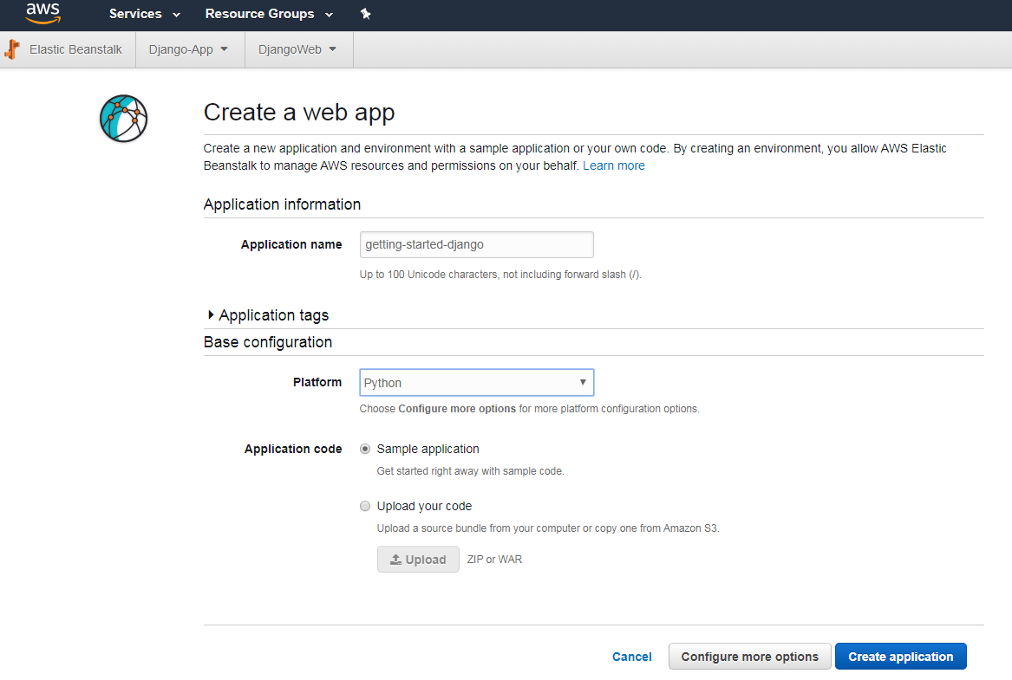

**Actions performed while creating EBS Application Environment**

1. Create environment 2. Create s3 buucket 3. Create security group 4. Create EIP 5. Health of environment being monitored 6. Add EC2 Instance to environment(takes few minutes) 7. Build stack 8. Succussfully launch environment-GettingStartedDjango-env It finally create application and its environment. Dashboard will look in Green denoting healthy status. Yellow shows warning. Event/s Red is severe and will need to be addressed. 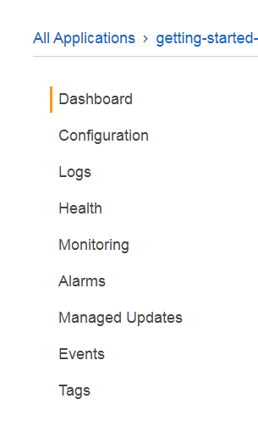 Explore the following pages to see the current state of your environment.**Monitoring**helps shows CPU Utilization and the statistics can be used to create alarm for monitoring. **Health** shows health information of EC2 instances running the application. **Configuration** shows the resources being used/provisioned by application. **Events** helps in getting error details or any information concerning application running status. In the event of any error occurance or to search for environment details, created Logs can be downloaded and searched. There are two types: 1. Last 100 lines and Full Logs. 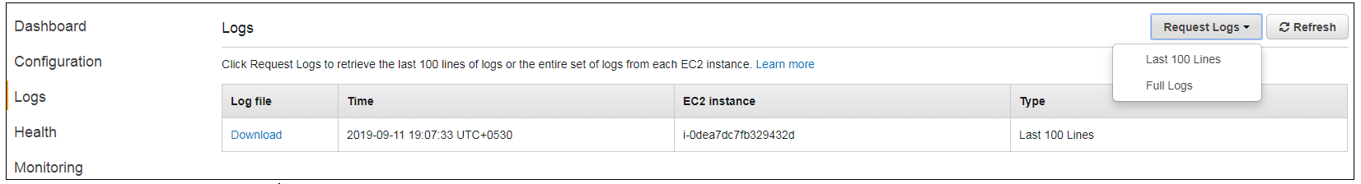

**View Environment Details from Dashboard**

After creating EBS application, you can view the application deployed by visting dashboard in the AWS Management Console. 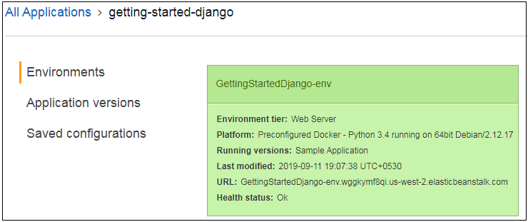

**Deploy a New Application Version**

Application new version can be deployed at any time. To update application version over created one, choose one of the matching environment:- 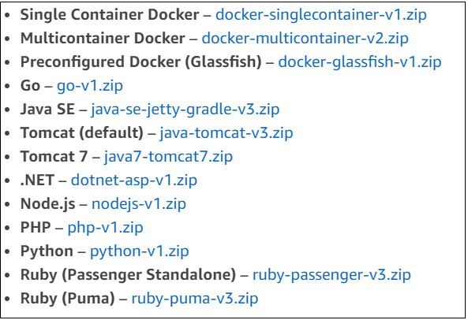 Choose a File for Upload. Console automatically fills in Version Label. Select to **Deploy** 